

January 5, 2018

Dr. Janet Sortor

Chief Academic Officer

Maine Community College System

323 State Street

Augusta, Maine 04330

Dr. Sortor:

In accordance with the Maine Community College Policy 304 and 304.1, the program review for the following program is attached:

Early Childhood Education

Sincerely,



Darin L. McGaw

Interim Academic Dean



Maine Community College System

Program Review

Washington County Community College Early Childhood Education

Date Reviewed ***January 2018***

1. **Cohort Enrollment Data:**

Early Childhood Education, AAS & Certificate 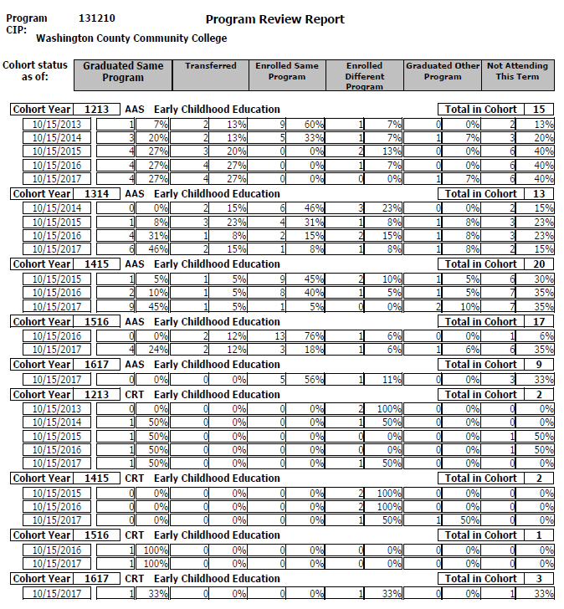

1. **Key Indicator Data**

WCCC has the only Early Childhood Education (ECE) program in Washington County. According to ECE Advisory Council members, public schools and early childhood programs such as Head Start and Washington County Children’s Program have a need for employees with an early childhood background to serve as Education Technician II’s, behavioral health professionals, and assistant teachers. Public school preschool teachers are required to have an educational background in early childhood education. Graduates of the ECE program gain positions at local schools as Ed. Tech II’s, while many continue their educations toward a baccalaureate degree and teacher certification. The target enrollment for WCCC’s ECE program is 18 students.

1. **Program Information**

WCCC’s Early Childhood Education (ECE) AAS Program provides graduates with a foundation of knowledge that includes theories and stages of child development, principles of guidance and discipline, developmentally appropriate curriculum planning for children with diverse abilities, and learning styles. The ECE program requires graduates to complete 400 hours of practical experience in at least two different early childhood age group settings. The coursework and practical experience prepares graduates to enter the field as para-professionals in early childhood programs, private or public. Graduates may also continue their education by transferring to a baccalaureate program to earn a teacher certification. Articulation agreements are in place with University of Maine Augusta and University of Maine Farmington.

WCCC’s Early Childhood Education (ECE) Certificate Program is a two-semester program with instructional topics covering subject areas that coordinate with those of the Council for Professional Recognition credential, the Child Development Associate (CDA). Graduates of the one-year certificate program will have completed a professional portfolio that includes documentation of competencies in eight areas of early childhood education including health and safety, guidance, curriculum planning, developmentally appropriate practice and professional and ethical management of programs. The ECE certificate program requirements include 200 of the 480 practical hours required for a CDA credential.

**Uniqueness and Strengths**

As stated above, WCCC has the only Early Childhood Education (ECE) program in Washington County. Graduates from the ECE program take positions in our local public schools, child and family service agencies, and/or continue their educations towards higher degrees.

WCCC is in a unique geographical and demographical location: the campus is sandwiched between two Passamaquoddy Tribal reservations, Indian Township and Pleasant Point. A number of students in the ECE program are Native American. Often our Native American students will set up their internships within their home communities and upon graduation establish careers as teachers, assistant teachers, or service providers for child and family programs. This is also true of the ECE student population in general. Most of our students’ desires are to complete their degrees and begin their careers working with children and families in their hometowns.

The WCCC campus is also geographically situated on the international border between Maine and New Brunswick, Canada. Individuals interested in early childhood education from New Brunswick attend WCCC to earn their ECE degree.

**Challenges**

Poverty - Washington County has among the highest rates of poverty and the lowest household incomes of all counties in the State of Maine. Our students often struggle to meet basic needs such as housing, transportation, food, and clothing. It is a challenge for many of our students to balance efforts to meet basic needs and also be mentally present and ready to learn in a college environment.

**Planned Steps for Continuous Improvement**

Members of the ECE Advisory Council, instructors, and ECE department head are currently reviewing program requirements and course content. Recommended changes to the program and curriculum will be submitted to WCCC’s Academic Curriculum Committee for implementation in 2018. Currently the ECE AAS program includes 400 hours of practical experience totaling 12 credit hours toward course requirements. The goal is to reduce these practical hours from 400 to 200 hours. This will free up some credit hours for development of new ECE courses. Under consideration are courses designed to instruct students about emergent literacy, early numeracy, and understanding STEM and how children use it.

There is ongoing discussion with WCCC administration and facilities about the possibility of dedicating instructional space at WCCC for an ECE lab classroom. This classroom space would provide an opportunity for students to practice, hands on, setting up developmentally appropriate environments and activities for young children.

# **Source:** JobsEQ®, <http://www.chmuraecon.com/jobseq> Occupation Report for Preschool Teachers, Except Special Education Maine (Data Excerpts) Copyright ©2017 Chmura Economics & Analytics, All Rights Reserved.

# Definition of Preschool Teachers, Except Special Education, SOC 25-2011

Instruct preschool-aged children in activities designed to promote social, physical, and intellectual growth needed for primary school in preschool, day care center, or other child development facility. Substitute teachers are included in "Teachers and Instructors, All Other" (25-3099). May be required to hold State certification. Excludes "Childcare Workers" (39-9011) and "Special Education Teachers" (25-2050).

# Occupation Snapshot

As of 2017Q2, total employment for Preschool Teachers, Except Special Education in Maine was 1,762. Over the past three years, this occupation added 181 jobs in the region and is expected to increase by 0 jobs over the next seven years, or at an annual average rate of 0.0%.

| **Occupation Snapshot of Preschool Teachers, Except Special Education in Maine** | | | | | | | | | | |
| --- | --- | --- | --- | --- | --- | --- | --- | --- | --- | --- |
| **Current** | | | | | **Historical** | | **Forecast** | | | |
| **Four Quarters Ending with 2017q2** | | | **2017q2** | | **Total Change over the Last 3 Years** | **Avg Ann % Chg in Empl 2014q2-2017q2** | **Over the Next 7 Years** | | | |
| **Empl** | **Avg. Annual Wages1** | **Location Quotient** | **Unempl** | **Unempl Rate** | **Empl** | **Maine** | **Current Online Job Ads2** | **Total Repl Demand** | **Total Growth Demand** | **Avg. Annual Growth Percent** |
| 1,762 | $33,200 | 0.92 | 45 | 2.4% | 181 | 3.7% | 132 | 340 | 0 | 0.0% |

Source: [JobsEQ®](http://www.chmuraecon.com/jobseq)

Data as of 2017Q2 unless noted otherwise

Note: Figures may not sum due to rounding.

1. Occupation wages are as of 2016 and should be taken as the average for all Covered Employment

2. Data represent found online ads active within the last thirty days in any zip code intersecting or within the selected region; data represents a sampling rather than the complete universe of postings.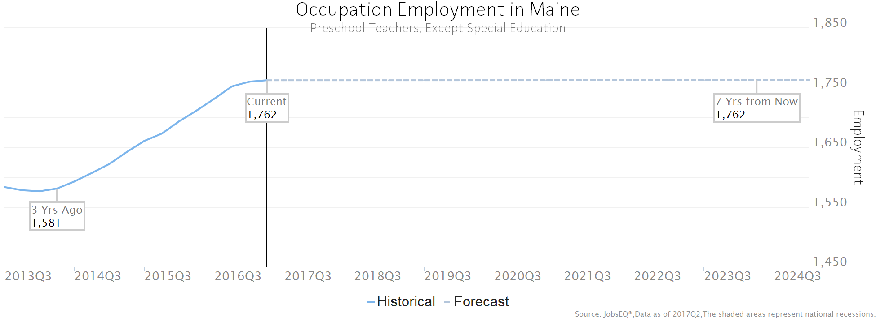

Occupation employment data are estimated via industry employment data and the industry/occupation mix. Industry employment data are derived from the Quarterly Census of Employment and Wages, provided by the Bureau of Labor Statistics and currently updated through 2016Q4, imputed where necessary with preliminary estimates updated to 2017Q2. Wages by occupation are as of 2016 provided by the BLS and imputed where necessary. Forecast employment growth uses national projections from the Bureau of Labor Statistics adapted for regional growth patterns. Occupation unemployment figures are imputed by Chmura.

# Employment by Industry

The following chart and table illustrate the industries in Maine which most employ Preschool Teachers, Except Special Education. The single industry most employing this occupation in the region is Child Day Care Services, NAICS 6244. This industry employs 1,113 Preschool Teachers, Except Special Education—employment which is expected to increase by 6 jobs over the next ten years; furthermore, 307 additional new workers in this occupation will be needed for this industry due to replacement demand, that is, to replace workers in this occupation and industry that retire or move into a different occupation.

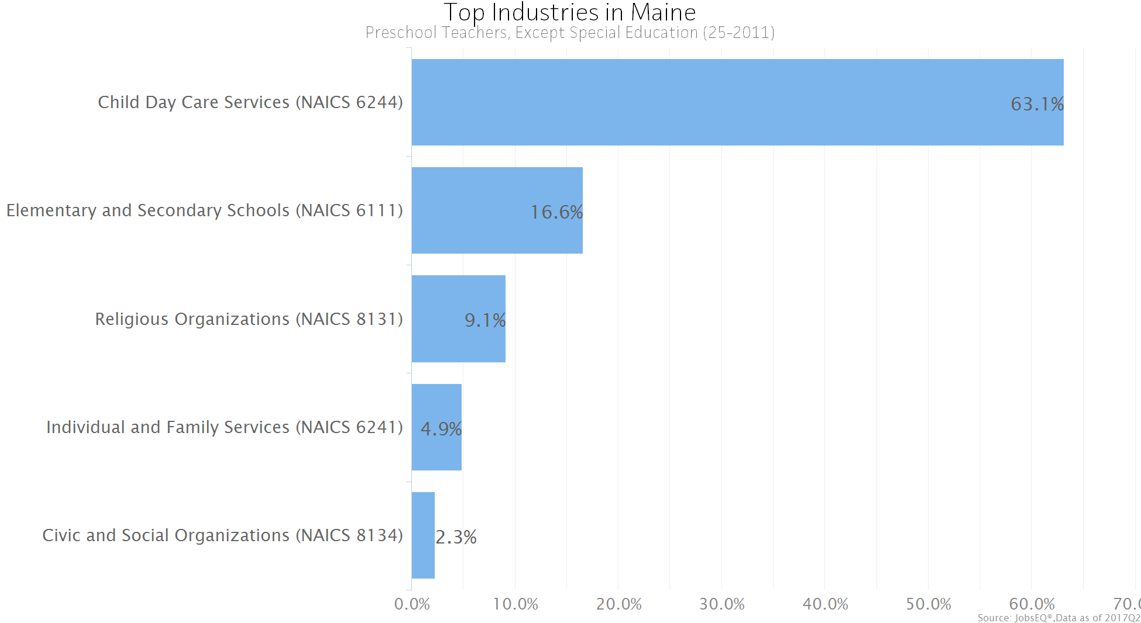

Occupation employment data are estimated via industry employment data and the industry/occupation mix. Industry employment data are derived from the Quarterly Census of Employment and Wages, provided by the Bureau of Labor Statistics and currently updated through 2016Q4, imputed where necessary with preliminary estimates updated to 2017Q2.

| **Top Industry Distribution for Preschool Teachers, Except Special Education (25-2011) in Maine** | | | | | |
| --- | --- | --- | --- | --- | --- |
| **NAICS Code** | **Industry Title** | **Current Occupation Employment** | **10-Year Repl Demand** | **10-Year Growth Demand** | **10-Year Total Demand** |
| 6244 | Child Day Care Services | 1,113 | 307 | 6 | 314 |
| 6111 | Elementary and Secondary Schools | 292 | 80 | -5 | 75 |
| 8131 | Religious Organizations | 161 | 44 | -5 | 38 |
| 6241 | Individual and Family Services | 86 | 24 | 6 | 31 |
| 8134 | Civic and Social Organizations | 40 | 11 | -3 | 8 |
| 8133 | Social Advocacy Organizations | 12 | 3 | 0 | 3 |
| 6113 | Colleges, Universities, and Professional Schools | 9 | 3 | 0 | 3 |
|  | -All Others- | 49 | 14 | 1 | 15 |

Source: [JobsEQ®](http://www.chmuraecon.com/jobseq)

Data as of 2017Q2 except wages which are as of 2016. Note that occupation-by-industry wages represent adjusted national data and may not be consistent with regional, all-industry occupation wages shown elsewhere in JobsEQ.

Note: Figures may not sum due to rounding.

Occupation employment data are estimated via industry employment data and the industry/occupation mix. Industry employment data are derived from the Quarterly Census of Employment and Wages, provided by the Bureau of Labor Statistics and currently updated through 2016Q4, imputed where necessary with preliminary estimates updated to 2017Q2. Forecast employment growth uses national projections from the Bureau of Labor Statistics adapted for regional growth patterns.

Wages

The average (mean) annual wage for Preschool Teachers, Except Special Education was $33,200 in Maine as of 2016. For the same year, average entry level wages were approximately $24,600 compared to an average of $37,500 for experienced workers.

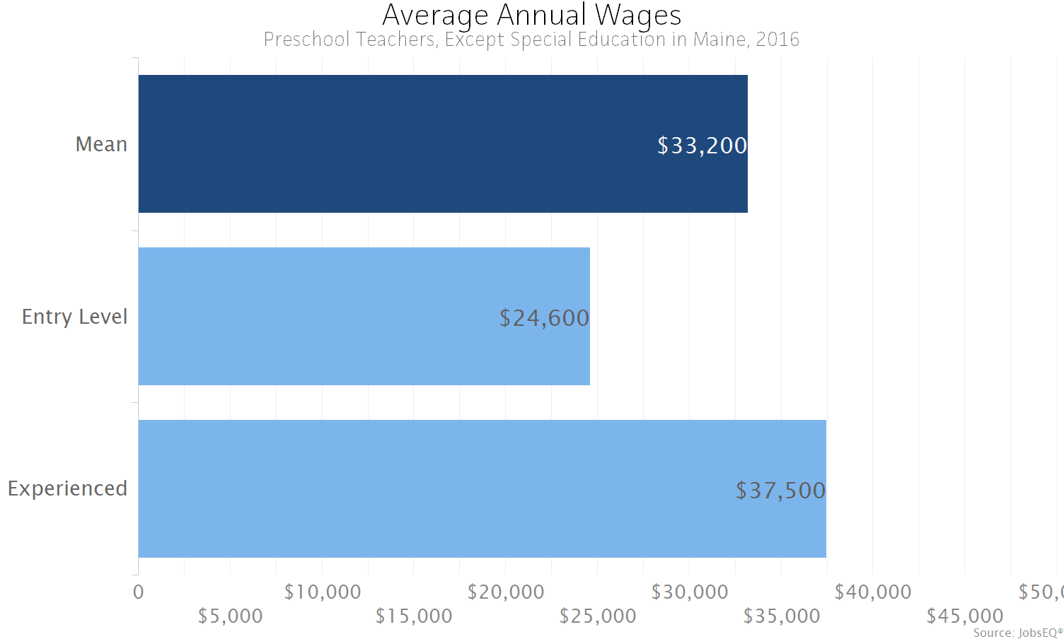

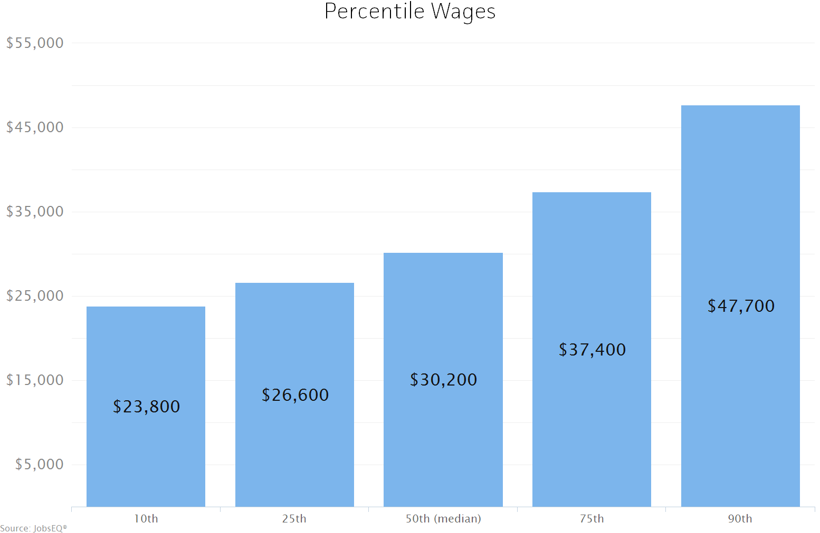

Occupation wages (mean, median, and percentiles) are as of 2016 provided by the BLS, modified and imputed by Chmura where necessary. Entry-level and experienced wages are derived from these source data, computed by Chmura.