

September 14, 2018

Dr. Janet Sortor

Chief Academic Officer

Maine Community College System

323 State Street

Augusta, Maine 04330

Dr. Sortor:

In accordance with the Maine Community College Policy 304 and 304.1, the program review for the following program is attached:

Human Services

Sincerely,



Darin L. McGaw

Interim Academic Dean



**CIP Code: 440000**

**Program Review Report**

**Washington County Community College**

**Cohort status as of:**

|  |  |  |  |  |  |
| --- | --- | --- | --- | --- | --- |
| **Graduated Same Program** | **Transferred** | **Enrolled Same Program** | **Enrolled Different Program** | **Graduated Other Program** | **Not Attending This Term** |

**HUS AAS Human Services**

Cohort Year 1213

Total in Cohort 26

|  |  |  |  |  |  |  |  |  |  |  |  |  |  |  |
| --- | --- | --- | --- | --- | --- | --- | --- | --- | --- | --- | --- | --- | --- | --- |
|  | 10/15/2013 |  | 0 | 0% | 2 | 8% | 22 | 85% | 1 | 4% | 0 | 0% | 1 | 4% |
| 10/15/2014 | 11 | 42% | 1 | 4% | 10 | 38% | 1 | 4% | 1 | 4% | 2 | 8% |
| 10/15/2015 | 18 | 69% | 1 | 4% | 2 | 8% | 1 | 4% | 1 | 4% | 3 | 12% |
| 10/15/2016 | 19 | 73% | 0 | 0% | 1 | 4% | 2 | 8% | 1 | 4% | 3 | 12% |
| 10/15/2017 | 20 | 77% | 1 | 4% | 0 | 0% | 0 | 0% | 2 | 8% | 3 | 12% |

Cohort Year 1314

Total in Cohort 15

|  |  |  |  |  |  |  |  |  |  |  |  |  |  |  |
| --- | --- | --- | --- | --- | --- | --- | --- | --- | --- | --- | --- | --- | --- | --- |
|  | 10/15/2014 |  | 0 | 0% | 2 | 13% | 8 | 53% | 2 | 13% | 0 | 0% | 3 | 20% |
| 10/15/2015 | 5 | 33% | 2 | 13% | 2 | 13% | 0 | 0% | 0 | 0% | 6 | 40% |
| 10/15/2016 | 5 | 33% | 2 | 13% | 2 | 13% | 0 | 0% | 0 | 0% | 6 | 40% |
| 10/15/2017 | 5 | 33% | 2 | 13% | 1 | 7% | 0 | 0% | 0 | 0% | 7 | 47% |

Cohort Year 1415

Total in Cohort 22

|  |  |  |  |  |  |  |  |  |  |  |  |  |  |  |
| --- | --- | --- | --- | --- | --- | --- | --- | --- | --- | --- | --- | --- | --- | --- |
|  | 10/15/2015 |  | 1 | 5% | 5 | 23% | 7 | 32% | 2 | 9% | 3 | 14% | 4 | 18% |
| 10/15/2016 | 7 | 32% | 4 | 18% | 0 | 0% | 2 | 9% | 5 | 23% | 4 | 18% |
| 10/15/2017 | 7 | 32% | 4 | 18% | 0 | 0% | 0 | 0% | 7 | 32% | 4 | 18% |

Cohort Year 1516

Total in Cohort 14

|  |  |  |  |  |  |  |  |  |  |  |  |  |  |  |
| --- | --- | --- | --- | --- | --- | --- | --- | --- | --- | --- | --- | --- | --- | --- |
|  | 10/15/2016 |  | 0 | 0% | 1 | 7% | 10 | 71% | 0 | 0% | 1 | 7% | 2 | 14% |
| 10/15/2017 | 4 | 29% | 1 | 7% | 3 | 21% | 1 | 7% | 1 | 7% | 4 | 29% |

Cohort Year 1617

Total in Cohort

3

|  |  |  |  |  |  |  |  |  |  |  |  |  |  |  |
| --- | --- | --- | --- | --- | --- | --- | --- | --- | --- | --- | --- | --- | --- | --- |
|  | 10/15/2017 |  | 0 | 0% | 0 | 0% | 0 | 0% | 0 | 0% | 0 | 0% | 3 | 100% |

1. **Key Indicator Data**

WCCC operates a two-year Associate in Applied Science degree program concentrating in Human Services (H.S.). According to the H.S. Advisory Council membership, MHRT/C certification in the State of Maine is undergoing redesign. WCCC will need to incorporate the new certification requirements into our program. One of the coming changes will be to require new Mental Health and Rehabilitation Technicians to participate in continuing education to acquire recertification. WCCC is aptly poised to provide that recertification training in the region. The Council also indicates that there is much community interest in the alcohol and drug counseling certification (CADC) that is currently a potential outcome of the program. WCCC will continue to pursue the details of this possibility with the State of Maine. Graduates of the Human Services program currently gain positions in the county as case managers, human services specialists, crisis workers, child welfare workers, and substance abuse counselors. The target enrollment for WCCC’s Human Services program is 18 students.

1. **Program Information**

WCCC’s Human Services (HS) AAS Program provides graduates with a foundation of knowledge that includes service delivery and the understanding of human growth and development. Students are prepared to enter the human services or medical fields as entry-level caseworkers. The program provides opportunities for personal and professional growth through applied classroom instruction, community involvement and practical experiences under the direct supervision of professionals in local agencies. Graduates may also continue their education by transferring to a baccalaureate program, as articulation agreements are in place with several four-year institutions. Graduates of the Human Services Program are eligible for the MHRT/C (Mental Health Rehabilitation Technician/Community) upon completion of the program and also meets the requirements for the CADC (Certified Alcohol and Drug Counselor).

**Uniqueness and Strengths**

The majority of our students’ desire to complete their degrees and begin their careers working within their hometowns. WCCC is in a unique geographical location with demographic challenges: the campus is located between two Passamaquoddy Tribal reservations, Indian Township and Pleasant Point. A number of students in the Human Services program are Native American students. Often our Native American students will set up their internships within their home communities and upon graduation establish careers there. This is also true of the Human Services student population in general. Our graduates have a new option on campus made possible through a partnership with New England College. Students may enroll in a Bachelors degree in Psychology after completing the AAS in Human Services and take their course with NEC through distance education here on campus.

WCCC’s campus is geographically situated on the international border between Maine and New Brunswick, Canada. Individuals interested in Human Services from New Brunswick attend WCCC to earn their Human Services degree. Washington County has a strong Human Services industry; there are many agencies and organizations providing services to the community, allowing individuals a variety of choices regarding employment such as case managers in the human services or medical fields as well as agency coordinators, human services specialists and substance abuse counselors. A number of students within the program have at some point in their lives received social services, and the degree offers them an opportunity to achieve their education and give back to their community.

**Challenges**

Poverty - Washington County has among the highest rates of poverty and the lowest household incomes of all counties in the State of Maine. Our students often struggle to meet basic needs such as housing, transportation, food, and clothing. It is a challenge for many of our students to balance efforts to meet basic needs and also be present and ready to learn in a college environment. The college attempts to mitigate these challenges by providing enhanced staff development opportunities for our faculty to inform and sensitize them to the struggles and realities of our student’s daily lives. The very nature of the Human Services program is to provide training opportunities and experiences to our students so that they may be sensitized to the needs of our community members as well.

WCCC shares its service area with the University of Maine Machias, which offers an Associate of Arts degree in Liberal Studies with a concentration in Mental Health and Rehabilitation. Washington County Community College serves students in eastern Washington County while the University of Maine Machias serves western Washington County because of barriers such as transportation, internet connectivity and speed for distance learning options and availability of childcare resources, just to name a few .

During the inception of the Human Services program, a large number of students were enrolled, but 31% did not graduate on time. Over the past six years, up until very recently, recruitment numbers were good, but many students either became part-time, transferred to another program, or dropped out. Last year, student numbers were very low. This year’s new cohort has seven students enrolled, three of which are returning students who had previously left. The other four students are new with 86% of the new cohort being full-time students. Seventeen total students are currently enrolled in Human Services with twelve being full-time and five being part-time. The college is dedicating resources to focus on adult learner outreach in our service area. Our plan is to enhance enrollment in Human Services and other program areas on campus by expanding our efforts to reach over 7000 adult learners in Washington County in immediate need of further education, training and enhanced career opportunities. We will also collaborate with the University of Maine Machias to work together to overcome the barriers our students encounter in the pursuit of this program as well as other programs.

**Planned Steps for Continuous Improvement**

Members of the Human Services Advisory Council, instructors, and the Department Chair are currently reviewing program requirements and course content to coincide with a review by the Muskie School that considers recent changes in the State of Maine requirements for the MHRT/C credential. Recommended changes to the program and curriculum will be submitted to WCCC’s Academic Curriculum Committee for implementation in 2019.

WCCC is collaborating with the University of Maine at Machias to explore combining our students to create an opportunity to obtain their Behavioral Health Professional credential. This course is delivered through a distance learning process that is delivered live every other week on each campus and synchronously at the other campus.

# Definition of Social and Human Service Assistants, SOC 21-1093

Assist in providing client services in a wide variety of fields, such as psychology, rehabilitation, or social work, including support for families. May assist clients in identifying and obtaining available benefits and social and community services. May assist social workers with developing, organizing, and conducting programs to prevent and resolve problems relevant to substance abuse, human relationships, rehabilitation, or dependent care. Excludes "Rehabilitation Counselors" (21-1015), "Psychiatric Technicians" (29-2053), "Personal Care Aides" (39-9021), and "Eligibility Interviewers, Government Programs" (43-4061).

Occupation Snapshot

As of 2018Q1, total employment for Social and Human Service Assistants in the WCCC Region was 42. Over the past three years, this occupation added 9 jobs in the region and is expected to increase by 3 jobs over the next seven years, or at an annual average rate of 1.1%.

| **Occupation Snapshot of Social and Human Service Assistants in WCCC Region, 2018q1** | | | | | | | | | | | | |
| --- | --- | --- | --- | --- | --- | --- | --- | --- | --- | --- | --- | --- |
| **Current** | | | | | | **3-Year History** | | **7-Year Forecast** | | | | |
| **Four Quarters Ending with 2018q1** | | | **-----2018q1-----** | |  | **Total Change** | **Avg Ann % Chg in Empl** |  | **--Separations--** | | **---Growth---** | |
| **Empl** | **Avg Ann Wages1** | **LQ** | **Unempl** | **Unempl Rate** | **Online Job Ads2** | **Empl** | **Region** | **Total New Demand** | **Exits** | **Transfers** | **Empl** | **Avg Ann Rate** |
| 42 | $33,600 | 1.43 | 2 | 3.7% | 7 | 9 | 8.5% | 40 | 14 | 22 | 3 | 1.1% |

Source: [JobsEQ®](http://www.chmuraecon.com/jobseq)

Data as of 2018Q1 unless noted otherwise

Note: Figures may not sum due to rounding.

1. Occupation wages are as of 2017 and should be taken as the average for all Covered Employment

2. Data represent found online ads active within the last thirty days in the selected region; data represents a sampling rather than the complete universe of postings. Ads lacking zip code information but designating a place (city, town, etc.) may be assigned to the zip code with greatest employment in that place for queries in this analytic. Due to alternative county-assignment algorithms, ad counts in this analytic may not match that shown in RTI (nor in the popup window ad list).

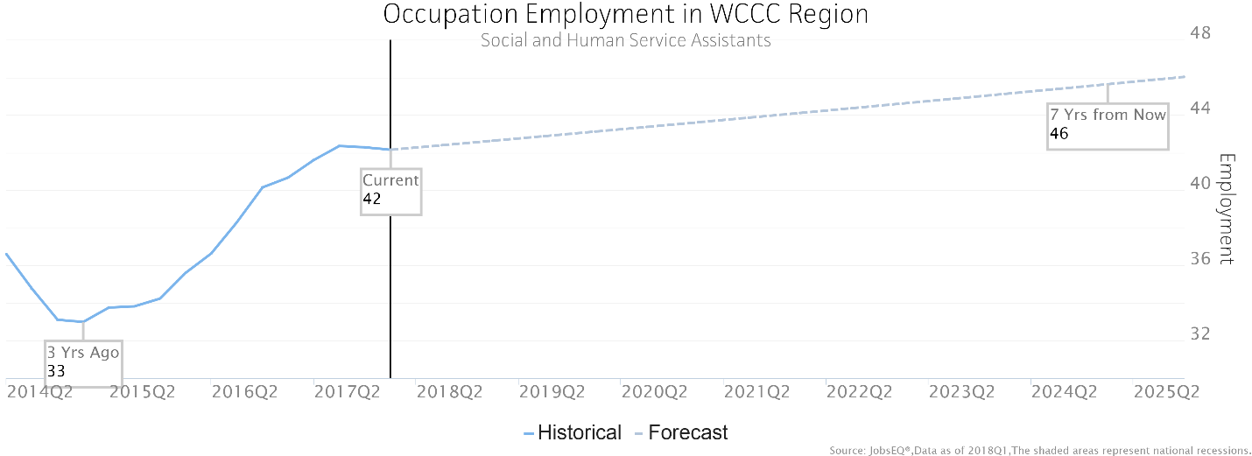

Occupation employment data are estimated via industry employment data and the industry/occupation mix. Industry employment data are derived from the Quarterly Census of Employment and Wages, provided by the Bureau of Labor Statistics and currently updated through 2017Q3, imputed where necessary with preliminary estimates updated to 2018Q1. Wages by occupation are as of 2017 provided by the BLS and imputed where necessary. Forecast employment growth uses national projections from the Bureau of Labor Statistics adapted for regional growth patterns. Occupation unemployment figures are imputed by Chmura.

# Employment by Industry

The following chart and table illustrate the industries in the WCCC Region which most employ Social and Human Service Assistants. The single industry most employing this occupation in the region is Individual and Family Services, NAICS 6241. This industry employs 19 Social and Human Service Assistants—employment which is expected to increase by 5 jobs over the next ten years; furthermore, 25 additional new workers in this occupation will be needed for this industry due to separation demand, that is, to replace workers in this occupation and industry that retire or move into a different occupation.

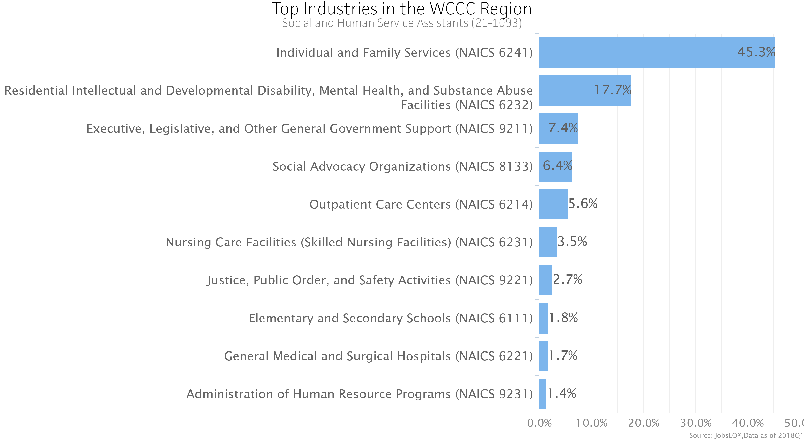

Occupation employment data are estimated via industry employment data and the industry/occupation mix. Industry employment data are derived from the Quarterly Census of Employment and Wages, provided by the Bureau of Labor Statistics and currently updated through 2017Q3, imputed where necessary with preliminary estimates updated to 2018Q1.

| **Top Industry Distribution for Social and Human Service Assistants (21-1093) in WCCC Region** | | | | | |
| --- | --- | --- | --- | --- | --- |
| **NAICS Code** | **Industry Title** | **Current Occupation Employment** | **10-Year Sep Demand** | **10-Year Growth Demand** | **10-Year Total Demand** |
| 6241 | Individual and Family Services | 19 | 25 | 5 | 30 |
| 6232 | Residential Intellectual and Developmental Disability, Mental Health, and Substance Abuse Facilities | 7 | 9 | 0 | 9 |
| 9211 | Executive, Legislative, and Other General Government Support | 3 | 3 | 0 | 3 |
| 8133 | Social Advocacy Organizations | 3 | 3 | 0 | 3 |
| 6214 | Outpatient Care Centers | 2 | 3 | 0 | 3 |
| 6231 | Nursing Care Facilities (Skilled Nursing Facilities) | 1 | 2 | 0 | 1 |
| 9221 | Justice, Public Order, and Safety Activities | 1 | 1 | 0 | 1 |
| 6111 | Elementary and Secondary Schools | 1 | 1 | 0 | 1 |
| 6221 | General Medical and Surgical Hospitals | 1 | 1 | 0 | 1 |
| 9231 | Administration of Human Resource Programs | 1 | 1 | 0 | 1 |
| 6117 | Educational Support Services | 1 | 1 | 0 | 1 |
|  | -All Others- | 2 | 3 | 0 | 3 |

Source: [JobsEQ®](http://www.chmuraecon.com/jobseq)

Data as of 2018Q1 except wages which are as of 2017. Note that occupation-by-industry wages represent adjusted national data and may not be consistent with regional, all-industry occupation wages shown elsewhere in JobsEQ.

Note: Figures may not sum due to rounding.

# Wages

The average (mean) annual wage for Social and Human Service Assistants was $33,600 in the WCCC Region as of 2017. For the same year, average entry-level wages were approximately $27,500 compared to an average of $36,600 for experienced workers.

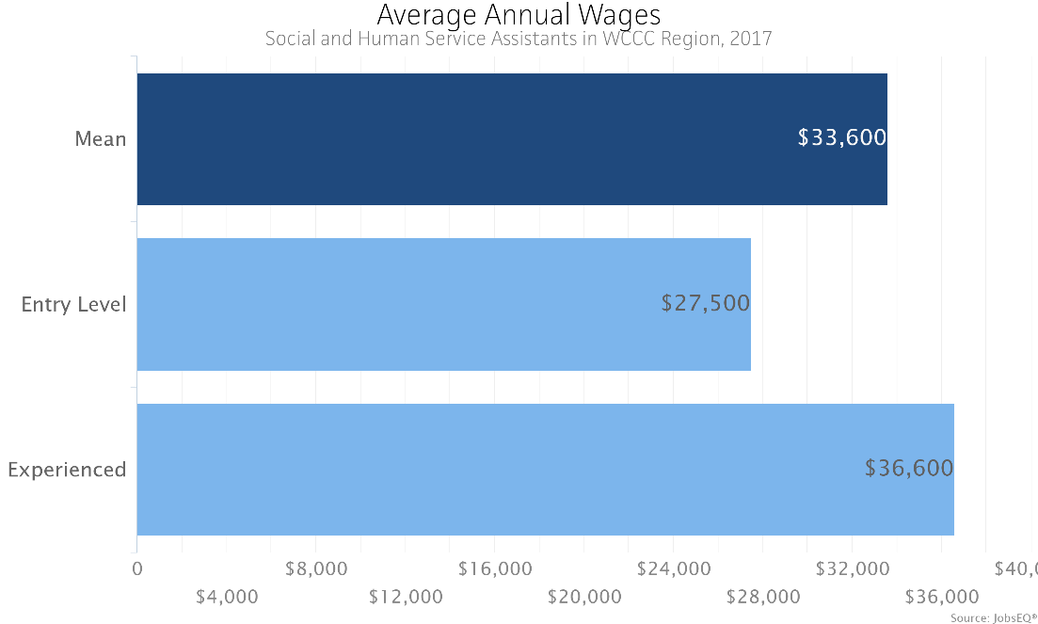

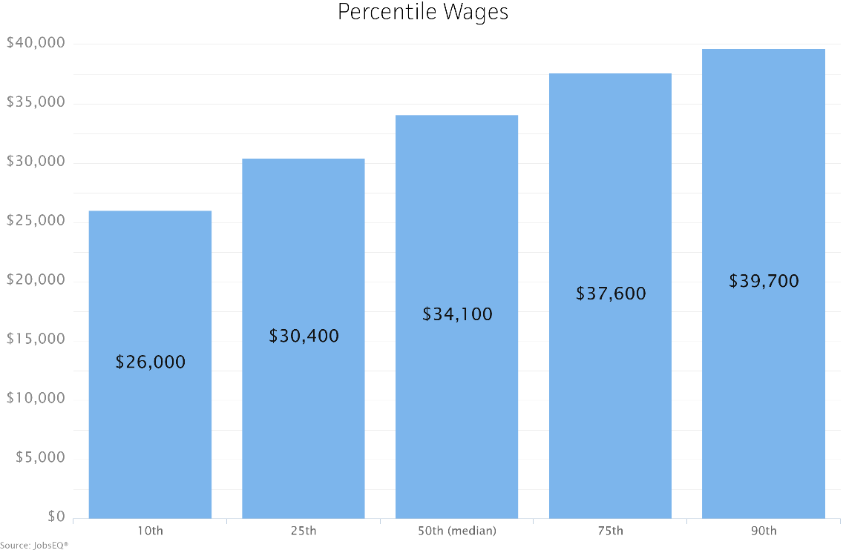

Occupation wages (mean, median, and percentiles) are as of 2017 provided by the BLS, modified and imputed by Chmura where necessary. Entry-level and experienced wages are derived from these source data, computed by Chmura